Time is the basis of the current problems of theoretical biology

What are biological clocks?

Biological clocks are organisms’ natural timing devices, regulating the cycle of circadian rhythms. They’re composed of specific [molecules](https://nigms.nih.gov/education/fact-sheets/Pages/circadian-rhythms.aspx#196) ([proteins](https://nigms.nih.gov/education/fact-sheets/Pages/circadian-rhythms.aspx#49)) that interact with cells throughout the body. Nearly every [tissue](https://nigms.nih.gov/education/fact-sheets/Pages/circadian-rhythms.aspx#85) and [organ](https://nigms.nih.gov/education/fact-sheets/Pages/circadian-rhythms.aspx#27) contains biological clocks. Researchers have identified similar [genes](https://nigms.nih.gov/education/fact-sheets/Pages/circadian-rhythms.aspx#127) in people, fruit flies, mice, plants, fungi, and several other organisms that make the clocks’ [molecular](https://nigms.nih.gov/education/fact-sheets/Pages/circadian-rhythms.aspx#202) components.

What is the master clock?

A master clock in the brain coordinates all the biological clocks in a living thing, keeping the clocks in sync. In [vertebrate](https://nigms.nih.gov/education/fact-sheets/Pages/circadian-rhythms.aspx#201) animals, including humans, the master clock is a group of about 20,000 [nerve cells](https://nigms.nih.gov/education/fact-sheets/Pages/circadian-rhythms.aspx#19) (neurons) that form a structure called the suprachiasmatic nucleus, or SCN. The SCN is in a part of the brain called the hypothalamus and receives direct input from the eyes.

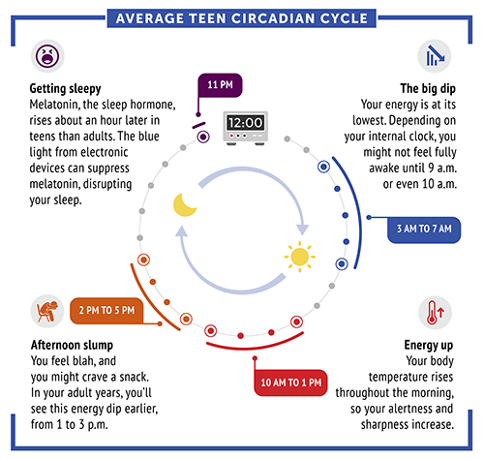

Circadian rhythm cycle of a typical teenager. Credit: NIGMS.

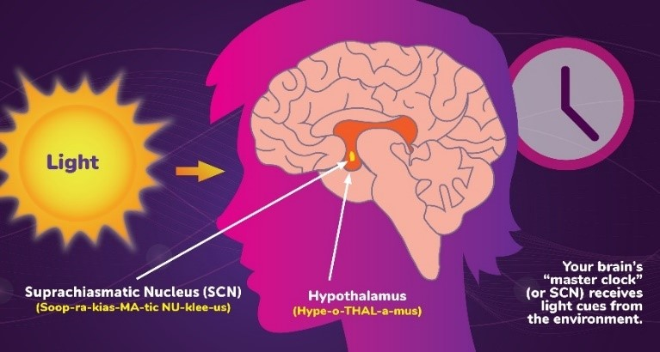

The master clock coordinates biological clocks from received light. Credit: NIGMS

Does the body make and keep its own circadian rhythms?

Yes, natural factors in your body produce circadian rhythms. For humans, some of the most important genes in this process are the *Period* and *Cryptochrome* genes. These genes code for proteins that build up in the cell’s [nucleus](https://nigms.nih.gov/education/fact-sheets/Pages/circadian-rhythms.aspx#25) at night and lessen during the day. Studies in fruit flies suggest that these proteins help activate feelings of wakefulness, alertness, and sleepiness. However, signals from the environment also affect circadian rhythms. For instance, exposure to light at a different time of day can reset when the body turns on *Period* and *Cryptochrome* genes.

How do circadian rhythms affect health?

Circadian rhythms can influence important functions in our bodies, such as:

* [Hormone](https://nigms.nih.gov/education/fact-sheets/Pages/circadian-rhythms.aspx#142) release
* Eating habits and digestion
* Body temperature

However, most people notice the effect of circadian rhythms on their sleep patterns. The SCN controls the production of melatonin, a hormone that makes you sleepy. It receives information about incoming light from the optic nerves, which relay information from the eyes to the brain. When there is less light—for example, at night—the SCN tells the brain to make more melatonin so you get drowsy.

In 2017, researchers Jeffrey C. Hall, Michael Rosbash, and Michael W. Young won the prestigious Nobel Prize for their circadian rhythms research. By studying fruit flies, which have a very similar genetic makeup to humans, they isolated a gene that helps control the body’s clock. The scientists showed that the gene produces a protein that builds up in cells overnight, then breaks down during the day. This process can affect when you sleep, how sharply your brain functions, and more. All three researchers were funded by NIGMS when these major discoveries were made.

What factors can change circadian rhythms?

Changes in our body and environmental factors can cause our circadian rhythms and the natural light-dark cycle to be out of sync. For example:

* Mutations or changes in certain genes can affect our biological clocks.
* Jet lag or shift work causes changes in the light-dark cycle.
* Light from electronic devices at night can confuse our biological clocks.

These changes can cause sleep disorders, and may lead to other chronic health conditions, such as obesity, diabetes, depression, bipolar disorder, and seasonal affective disorder.

How are circadian rhythms related to jet lag?

When you pass through different time zones, your biological clock will be different from the local time. For example, if you fly east from California to New York, you “lose” 3 hours. When you wake up at 7:00 a.m. on the East Coast, your biological clock is still running on West Coast time, so you feel the way you might at 4:00 a.m. Your biological clock will reset, but it will do so at a different rate. It often takes a few days for your biological clock to align with a new time zone. Adjusting after “gaining” time may be slightly easier than after “losing” time because the brain adjusts differently in the two situations.

How do researchers study circadian rhythms?

Scientists learn about circadian rhythms by studying humans and by using organisms with similar biological clock genes, such as fruit flies and mice. Researchers doing these experiments control the subject’s environment by altering light and dark periods. Then they look for changes in gene activity or other molecular signals. Scientists also study organisms with irregular circadian rhythms to identify which genetic components of biological clocks may be broken.

Understanding what makes biological clocks tick may lead to treatments for jet lag, sleep disorders, obesity, mental health disorders, and other health problems. It can also improve ways for people to adjust to nighttime shift work. Learning more about the genes responsible for circadian rhythms will also help us understand more about the human body.

What are the effects of biological rhythm disorders?

Biological rhythm disorders can affect a person’s health and feelings of well-being. Some of the effects include:

* anxiety
* daytime sleepiness
* [depression](https://www.healthline.com/health/depression)
* lower performance at work
* being more accident-prone
* lack of mental alertness
* increased risk for diabetes and obesity

[**Why do you need seven to eight hours of sleep? »**](https://www.healthline.com/health/science-sleep-why-you-need-7-8-hours-night)

Some of the world’s most significant human errors have happened during night shift work. These include the Chernobyl disaster and the Three Mile Island accident. Also, most single-driver accidents occur in the time before dawn, according to [Cornell University](http://ergo.human.cornell.edu/studentdownloads/dea3250pdfs/biorhythms.pdf).

From a brain and body perspective, our bodies are made to sleep at night. This is why we don’t have adaptations like night vision and an enhanced sense of smell and hearing like nocturnal animals do.

## Who is at risk for biological rhythm disorders?

An estimated [15 percent](https://sleepfoundation.org/shift-work/content/what-shift-work) of full-time workers in the United States work shifts. Shift workers are usually in service-related jobs that are vital to the health and movement of society. They’re also more likely to sleep fewer than six hours a night.

Those who do shift work, or work outside the typical 9 a.m. to 5 p.m. workday schedule, are especially at risk for biological rhythm disorders. Examples of professions that involve shift work include:

* healthcare workers
* drivers, pilots, and others who provide transportation
* food preparers and servers
* police officers
* firefighters

An [NSF survey](https://sleepfoundation.org/shift-work/content/what-shift-work) found that 63 percent of workers felt that their work allowed them to get enough sleep. The same survey also found 25 to 30 percent of shift workers have episodes of excessive sleepiness or insomnia.

Other groups of people who are at risk for a biological rhythm disorder include people who travel across time zones often or live in places that do not have as many hours of daylight, like Alaska.

For read: Reinberg A, Ashkenazi I. Concepts in human biological rhythms. Dialogues Clin Neurosci. 2003 Dec;5(4):327-42. doi: 10.31887/DCNS.2003.5.4/areinberg. PMID: 22033796; PMCID: PMC3181781.

Yujiro Yamanaka, Basic concepts and unique features of human circadian rhythms: implications for human health, Nutrition Reviews, Volume 78, Issue Supplement_3, December 2020, Pages 91–96, <https://doi.org/10.1093/nutrit/nuaa072>